|  |
| --- |
| **Dr. Basel Awwad**  Al-Fuheis, Jordan  Mob: 00962 795070082  E-mail : [basel.farahat@yahoo.com](mailto:basel.farahat@yahoo.com) |
|  |

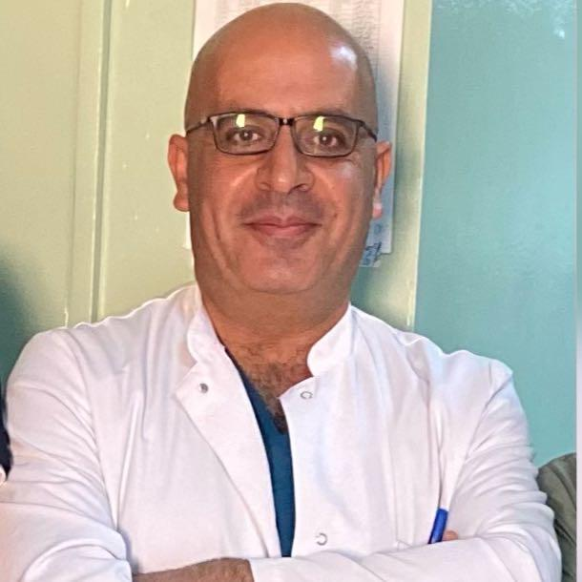

# CAREER OBJECTIVE:

Anesthetist doctor

##### PERSONAL DETAILS

## Nationality : Jordanian

## Marital Status: Married.

Date of Birth : August 14, 1975

##### ACADEMIC INFORMATION

|  |  |
| --- | --- |
| **1994-2001**  **2009** | Kharkiv state medical UniversityGeneral Medicine. (Ukraine) board in anesthesia and intensive care from Jordanian medical council |

##### Experience:

## 2004-2005 King Hussain medical center (residency) 2005-2006 Prince Hashem hospital 2006-2009 Princess Haya hospital 2009-2012 Anesthesia specialist at King Hussein medical center

## 25/3/2016  Anesthesia senior specialist at King Hussein medical center 1-05-2022- till now Anesthesia Consultant

## 2015-2022 Neuroanesthesia department head at Royal Jordanian medical services (KHMC)

07/2022-Till now Prince Ali Hospital

##### Specialty:

* Subspecialty in Neuroanesthesia
* Others: Major surgeries such as liver transplant and craniotomies and pediatric anesthesia, thoracic anesthesia, orthopedic anesthesia, gynecology, obstetrics anesthesia and regional anesthesia.

##### Achievements:

* First awake brain surgery in Jordan 2019
* Certified Lecturer assigned by royal Medical Center for the Doctors and Staff about how to deal with Patients who are infected with Covid-19

##### Publications:

In International Journal of Science Research: I was one of the participants in the publication research, during my Work at Royal medical Services, KHMC, Amman-Jordan

* Medulloblastoma: Recapitulate Divergent Tumoral Cells Dynasties.
* Olfactory Meningioma: the Godfather of Cognitive Impairment and behavioral Changes-epidemiological feature scrutinized.
* Ambispective incidence, Impact and risk factors of unintended Durotomy.
* Posterior fossa Tumors : Pandora’s Box Violated

##### LANGUAGES

* Arabic: mother tongue.
* English: Professional (speaking, writing and reading).
* Russian: Professional (speaking, writing and reading).

##### Training:

* 2012-2013 training fellowship at international neuroscience institute (Hannover Germany).
* 15/6/2018 to 15/7/2018 Britain training fellowship in difficult airway management under the supervision professor peter charters at Aintree hospital Liverpool

##### Courses

* Primary trauma care PTC and became instructor
* Advance trauma life support ATLS

##### Peace Participations:

* Participate in peace keeping forces in Liberia and Congo from 6-2008 to 1-2009

##### REFERENCES

1. DR. Gazi aldehayat

Senior consultant of anesthesia

[Aldehayat@yahoo.co.uk](mailto:Aldehayat@yahoo.co.uk)

00962772248855

1. Dr. Husam Faraj Makhamreh

Former President of the Jordan Society of Anesthesiologists

[husamfaraj4@yahoo.com](mailto:husamfaraj4@yahoo.com)

00962777712050

##### Documents:

Available upon request