# Profile

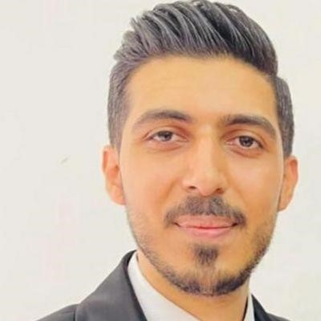

**DR Mahmoud**

**Samara**

UROLOGIST

**Details**

Zarqa

Jordan

(+)962798591005

mahmoodsamara12@gmail.com

NATIONALITY

Jordanian

DATE OF BIRTH

28/07/1993

**Skills**

Advance knowledge and expertise

in Urology, with focus on evidence

-

based medicine.

Proficient in accurate diagnosing

, treatment, planning, and

management of diverse Urologic

conditions and complications.

Extensive experience in

performing Urological surgeries

(

Endourology and open)

Strong communication and

interpersonal skills,

Ability to work effectively in

a team - based health care

environment, collaborating

with colleagues and other

professionals.

Meticulous attention to

detail, ensuring thorough

documentation and maintaining

accurate patient records.

**Languages**

Arabic

English

Highly skilled and dedicated urologist with extensive experience in providing comprehensive care to treat problems of the female urinary system and the male genitourinary tract.

Seeking a challenging position as a urologist to utilize my experience and contribute to the well-being of patients.

# Employment History

**Urology Specialist, King Hussein Cancer Center (Amman /Jordan)**

**Jan 2024 – Present**

**-**KHCC is the leading cancer center in the Middle East region providing adult and pediatric patients with state of the art comprehensive cancer care for all types of cancer

-Managed diverse cases in Uro-oncology and assisted in surgeries such as robotic radical prostatectomy

## Residency Program, King Abdullah University Hospital (Irbid, Jordan)

2 0 1 8 • 2 0 2 3

-completed intensive residency program in Urology at king Abdullah University Hospital, a prestigious teaching hospital.

- managed diverse cases including urological infection, male infertility, sexual health, urological cancers.

-Proficient in urological procedures (Endourology and open surgeries).

-Expertise in handling urological emergencies like testicular torsion, urological trauma, stones, hematuria, urinary retention.

-Assisted in urological surgeries such as radical cystectomy, radical prostatectomy, laparoscopic partial and radical nephrectomy, bladder augmentation.

- Actively participated in research projects and contributing to academic publications.

## Rotating Internship, King Abdullah University Hospital (Irbid, Jordan)

2 0 1 7 • 2 0 1 8

-Completed a comprehensive rotating Internship at king Abdullah University Hospital, gaining exposure in various medical specialties.

-Rotated through departments such as Internal medicine, Pediatrics, Surgery, Emergency medicine and Urology.

-Assisted in patient care, including performing physical examination,

interpreting diagnostic tests and prescribing appropriate treatments.

-Participated in medical procedures such as wound suturing, venipuncture, central line insertion, and endotracheal intubation.

-Engaged in multidisciplinary team discussion, attending medical rounds, and contributing to patient management plans.

# Education

**Higher specialization Degree in urology, Jordan University of science and technology/King Abdullah University Hospital, Irbid**

J U LY 2 0 1 8 • J U N E 2 0 2 3

**M.B.B.S faculty of medicine, Jordan University of science and technology, Irbid**

2 0 1 1 • 2 0 1 7

**Jordanian Board in Urology, Jordan Medical Council**

2023

**USMLE STEP 1 pass, ECFMG**

S E P T E M B E R 2 0 1 8

**BLS AHA CERTIFICATE (FEB/2024)**

# Conferences and Workshops

## Participated in the EAU23 (38th Annual Congress, Milan (Italy)

10TH -13TH of march 2023

## Participated in and met the objectives of the ESU/ESUI Hands-on Training course in urological ultrasound, Milan (Italy)

At the time of the 38th annual EAU Congress, 10-13 march 2023, Milan, Italy.

## Participated in 11th international Conference of the Jordanian Association of Urological Surgeons, Amman (Jordan)

2nd -4th of October 2019

## Participated in 12th international Conference of the Jordanian Association of Urological Surgeons, Amman (Jordan)

27th-29th October 2021

## Participated in 13th international Conference of the Jordanian Association of Urological Surgeons, Amman(Jordan)

20th -22nd October 2022

## Attended the conference Workshop titled Flexible Renoureteroscopy /Hands -on, Amman(Jordan)

27th October 2021

**PUBLICATION:**

A paper entitled "Predicting the Stone-Free Status of Percutaneous Nephrolithotomy with the Machine Learning System" get published in the International Journal of Nephrology and Renovascular Disease  
the paper can be accessed by the following link:  
<https://lnkd.in/dJvHXfpB>

**ORGANIZATION:**  
-European association of Urology.

Member · Dec 2022 – Present

-Jordan medical council.

Member 2018 – Present