CURRICULUM VITAE

Dr. Fadi Mahmoud Abu-Samra

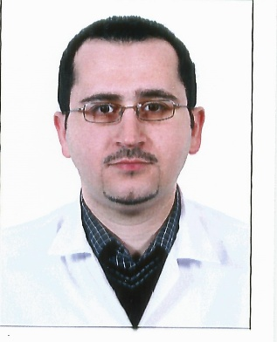

**PERSONAL DETAILS:**

**Full name:** Fadi Mahmoud Abu-Samra

**Date of birth:** 10 September 1979

**Place of birth:** Jerusalem / Palestine

**Gender:** Male

**Nationality**: Jordanian

**Marital status:** marriedwith three children.

**Religion**: Muslim

**LANGUAGES:**

Arabic (Mother language)

English (Fluent: Speaking, Writing and Reading)

# PRESENT ADDRESS

Kingdom of Bahrain - Manama.

Tel. (cellular): (0097335615045)

E-mail: (doc-fadi@hotmail.com), (fedadedo@yahoo.com)

# EARLY EDUCATION

* I lived the first 17 years of my life in the Kingdom of Saudi Arabia (Al-khobar). I’ve studied in Al-Siddiek elementary school then in Al-Khobar intermediate school then in Al-Azeezia private secondary school.
* I finished the secondary exam with honor-ship getting the second place over the eastern region. 99.5 %

# QUALIFICATION AND EDUCATION

November (2014) : Accreditation As a Consultant Radiologist from NAHRA (Kingdom of Bahrain)

June (2009) : the accreditation certificate from the Saudi commission for health specialties.

August (2008) : The Jordanian board in diagnostic radiology .

June (2008): High Specialty degree in Diagnostic Radiology from Jordan University of Science and Technology.

* June (2003): MBBS Degree in Medicine and Surgery from

Jordan University of Science and Technology (good average) 74.8 %.

* July (1997): High School Certificate, scientific stream

Ministry of Education, Kingdom of Saudi Arabia (99.5%)

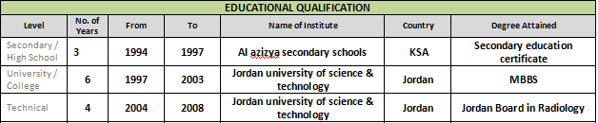

# TRAINING

* July 2003-June 2004: Internship: one year of postgraduate training done at Princess Basma, Rahma and Badeea Teaching Hospitals, including rotations in the Internal Medicine, General surgery, Emergency, Pediatrics and Obstetrics & Gynecology.
* July 2004 – June 2008

Diagnostic Radiology Residency Training at King Abdulla University hospital.

-During this residency program the training syllabus includes mainly medical physics, radiological anatomy, radiographic positioning, basic procedures, IVU, CT scan, ultrasound and reporting of plain films. Also good orientation about interpretation of MRI, CT scan, Mammogram, and Colored Doppler Ultrasound, Basics of Diagnostic Angiography and Interventional procedures.

* + The Department of Radiology at King Abdullah University Hospital runs a four-year residency-training program. It has a 1.5 T Toshiba MRI (Excel pianissimo), two Spiral C.T Scanners (Toshiba), four modern Ultrasound machines (ATL-HD1500 SonoCT), three Digital Fluoroscopic units (Toshiba), one Angiographic Lab. (Philips), X-ray Bone Densitometry (Lunar) and many rooms for routine plain films and IVU & Mammography.
  + The Nuclear medicine is a separate department contains two Gamma Cameras.
  + All these units are connected to the Picture Archiving and Communication system (PACS).

Assigned Duties (roles and responsibilities):

Clinical coverage of the radiology services consists of an extensive range of radiological procedures such as plain radiography, conventional (contrast studies), interventional (U/S &CT guided procedures), ultrasonography (including Doppler imaging), mammography, computed tomography (CT) and Magnetic Resonance imaging (MRI).  
Performance of general radiology reporting using PACS system.  
Function as a part of a multidisciplinary team working with radiographers, nurses, clerical and attendant staff in the interests of patient diagnosis and care. Consistently demonstrate effective interpersonal relationships with other x-ray staff and patients and handle problems sensitively.   
Responsible for ensuring medical and administrative policies within the radiology department are adhered to.

Performing reporting and supervision of multi-modality radiological investigations including:

* Conventional Radiography.
* Fluoroscopy.
* Ultrasound
* Mammography
* Doppler Sonography.
* CT scan
* MRI

Professional memberships:

Jordan Medical association - full member ship June 2004

Ministry of health on Jordan - Permanent license to practice medicine in Jordan July 2004

Member of the Radiological Society of Saudi Arabia (2005).

Jordan Medical Council - Recognized as a radiology specialist August 2008

Jordanian Radiological Society - Active member September 2008

**Employment Hx:**

* 2008-2009 -I helped in establishing a radiology department at a new Medical Center & Worked there as a radiologist at a Medical Center in Makkah.
* 2009-2010 -I worked as an assistant consultant at King Fahad specialist hospital in Dammam for one year.
* 2010- 2014 I worked as a radiologist & medical director, at a well known private medical group in Dammam (Al-Faraby Medical Group).
* November 2014 I joined Al-Kindi Specialised Hospital in Kingdom Of Bahrain As a Consultant Radiologist.
* November 2017 I joined Bahrain medical center in Muharraq as a Consultant Radiologist.
* July 2019 I joined Kims Bahrain Medical Center, In Muharraq as a Consultant Radiologist.
* September 2020 I joined London Breast Care Centre
* January 2022 I joined Al Hilal Hospital in Muharraq.

**Computer Skills:**

**Computer proficiency skills in:**

* **Microsoft Windows OS.**
* **Microsoft Office : Word / PowerPoint / Access / Excel**
* **PACS & teleradiology:** multiple systems.

**References are available upon request.**